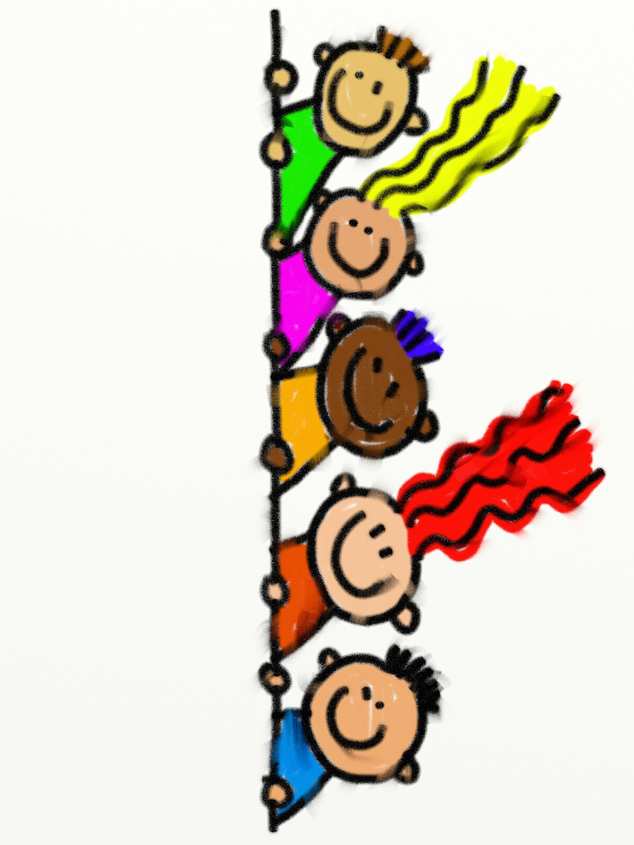 999

*The Resource Center at the Town of Mangonia Park*

*Phone: 561-764-3488*

Website: <https://tompfl.com/>

* Story Time
* Puppet Shows
* Computers
* Library Books & Services through the Palm Beach County Library System

1. Talking Books
2. Books by Mail

* Copying Services
* After school Tutoring

( Please call for more information and scheduling)