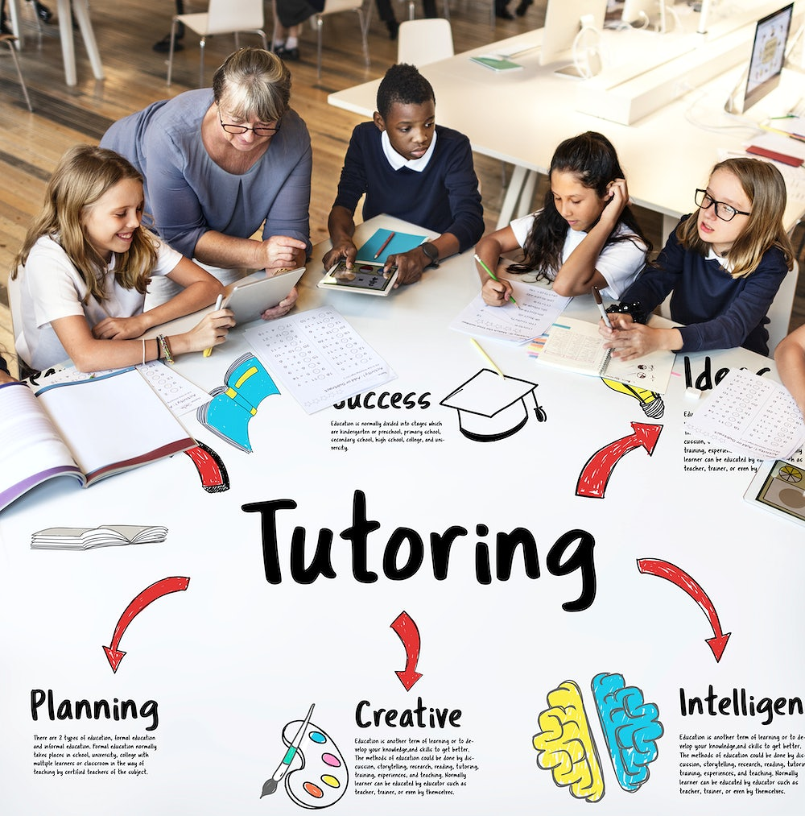

For more information call 561-764-3855

FREE

**Join us at Mangonia Park**

**Town Hall Resource Center**

**Monday – Friday**

**1755 E. Tiffany Drive for**

